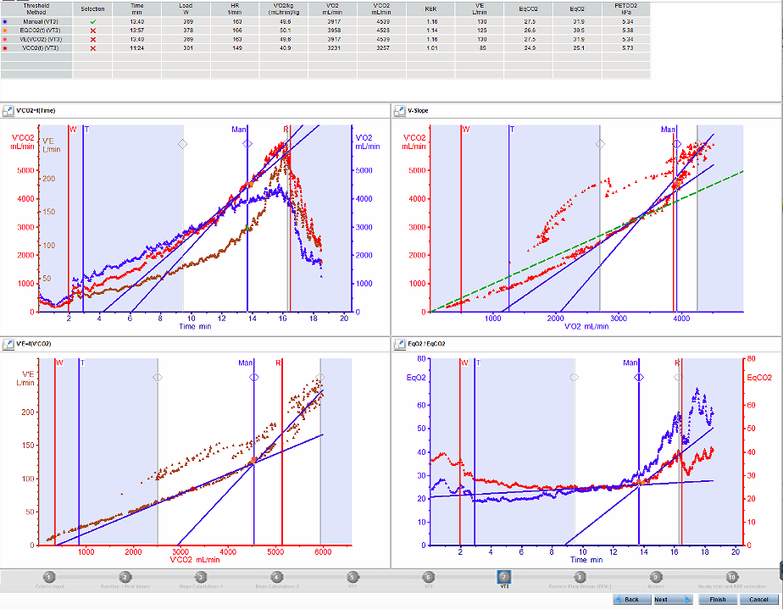
Determining the VE/VCO2 slope
This is the gradient of VE plotted over VCO2 and includes from the start of the exercise test up until VT3. The warmup should be excluded unless the test is very short and cannot be analysed without it.
Determining Threshold 2 - Respiratory Compensation Point (RCP)
The “respiratory compensation point” or “second ventilatory threshold” in the literature. At this threshold VE displays a further disproportionate increase relative to VCO2 as reflected in the increase in the EqCo2. Ventilation increases so much so that the PetCO2 begins to drop thus representing an “overcompensation”.
Primary Criteria
- Increase in EqCO2 and EqO2 at a faster rate, and decrease in PetCO2
Verification criteria
- Increase in VE at a faster rate, which is disproportionate to the increase in VCO2 and VO2
- Increase in the VE/VCO2 slope
- RER >1

Determining Threshold 1 – Gas Exchange Threshold (GET)
The point immediately preceding the onset of metabolic acidosis and associated shifts in gas exchange variables VCO2 and VE begin to escalate disproportionately to VO2 and workload. The ventilatory equivalent for VO2 (EqO2) increases, indicating a reduction in efficiency. The ventilatory equivalent for VCO2 remains stable as ventilation has increased proportionally to VCO2.
Primary Criteria
- Increase in PetO2 WITHOUT a decrease in PetCO2 (remains relatively stable)
- Increase in EqO2 while EqCO2 remains stable
Verification Criteria
- RER of ≤ 1, usually 0.80-1.0
- Break point in the V-slope, VE and VCO2 trajectory

